How to Install Python and Visual Studio Code.
Step 1:
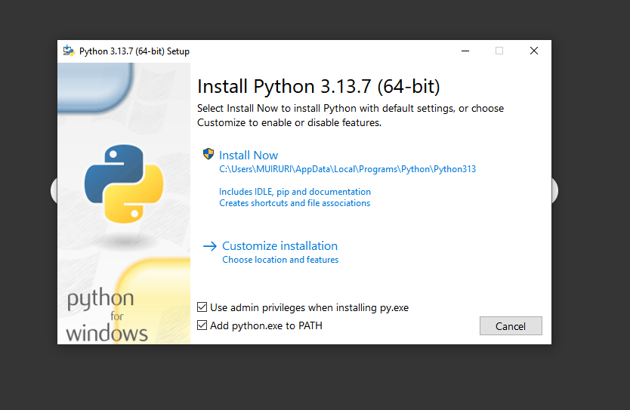
Ensure that the both bottom options are selected.
Select the Install now option for beginner’s and customize installation for more advanced controls.
Step 2:
After you click yes when prompted to make changes to your computer it will show installing load screen
Step 3
After the installation is complete it should be ready to start.

